Working with crypto++ JNI in Scapi

# Visual studio

1. Take existing code + solution of JavaInterface project.
2. Take crypto++ project, or take only the h files of crypto++.
3. Take compiled lib file of crypto++ called cryptlib.lib. This file is complied so it is compatible with the solution of the JavaInterface.
4. Place cryptlib.lib in some location on your computer.
5. Change in the project settings so it will take the relevant h files (of crypto++ and jni.h) and lib file from the right path as follows.

Right click on JavaInterface project and press properties

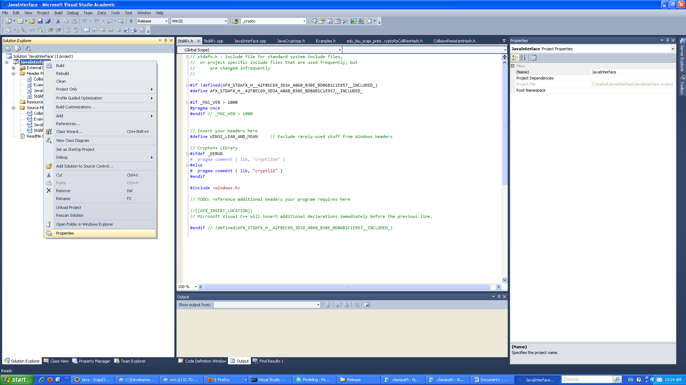

Go to Include Directories->edit

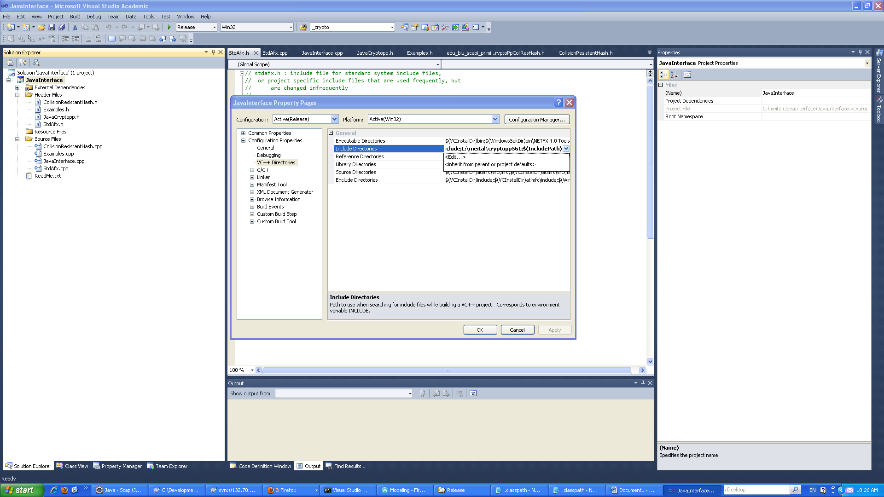

Locate your jni.h on your computer and add it to the include directories as follows.

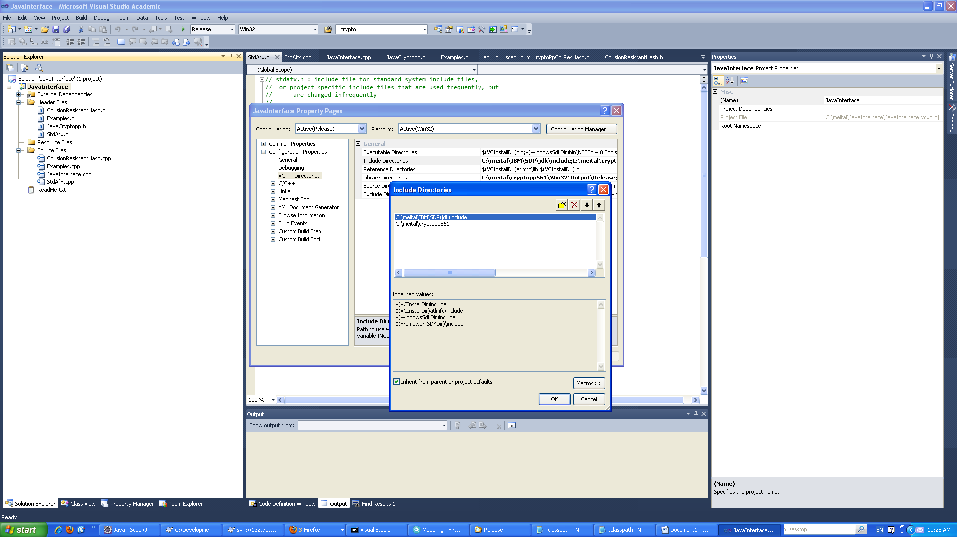

Locate your crypto++ header files on your computer and add it to the include directories as follows.

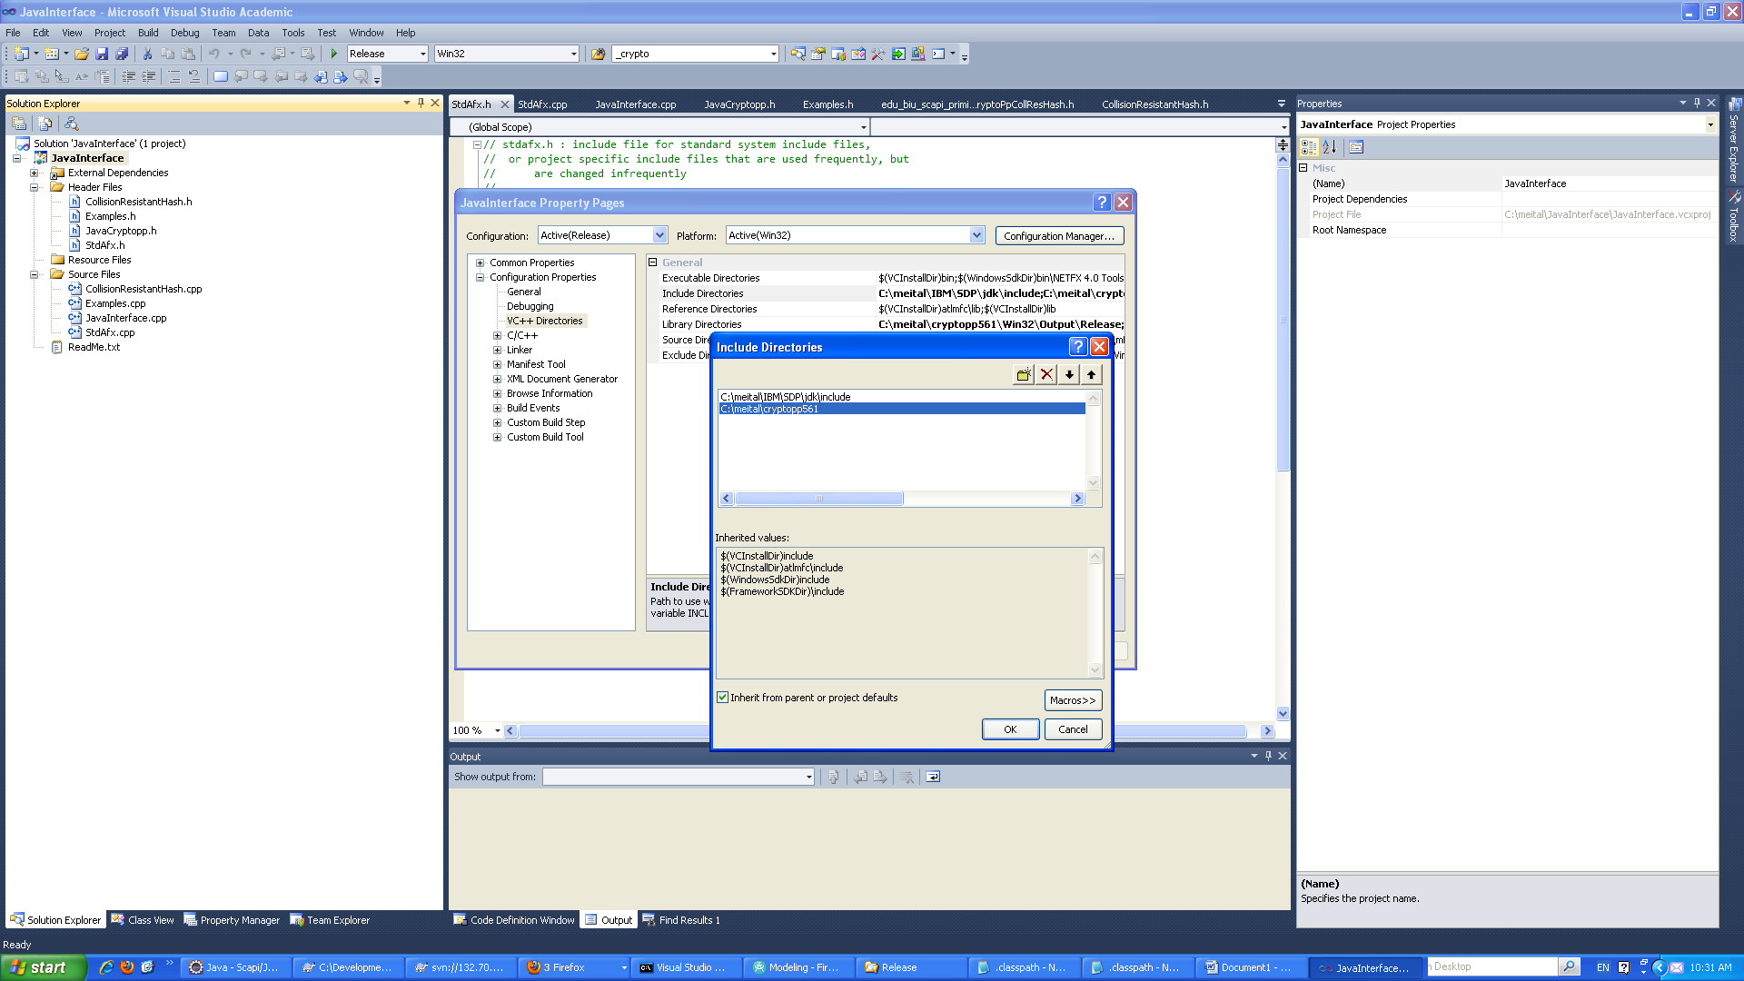

Go to Library Directories->edit

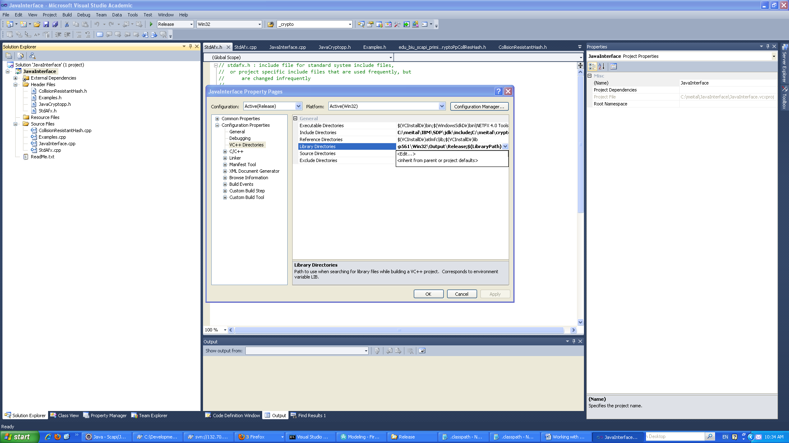

Locate your cryptli.lib file on your computer and add it to the Library directories as follows.

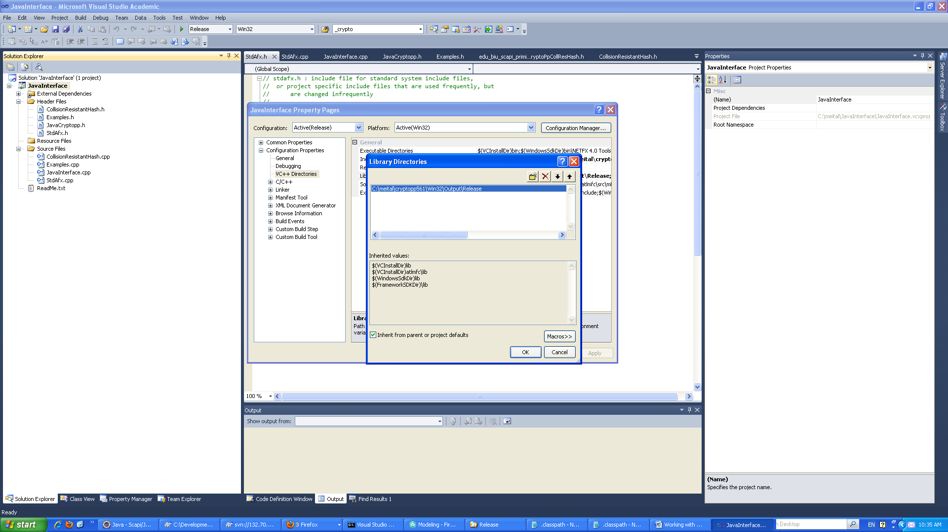

## Generating h file

1. **Create an external tool**. This should be done once.

This h file is generated using the javah tool. For an easy use a simple external tool should be defined in eclipse as follows.

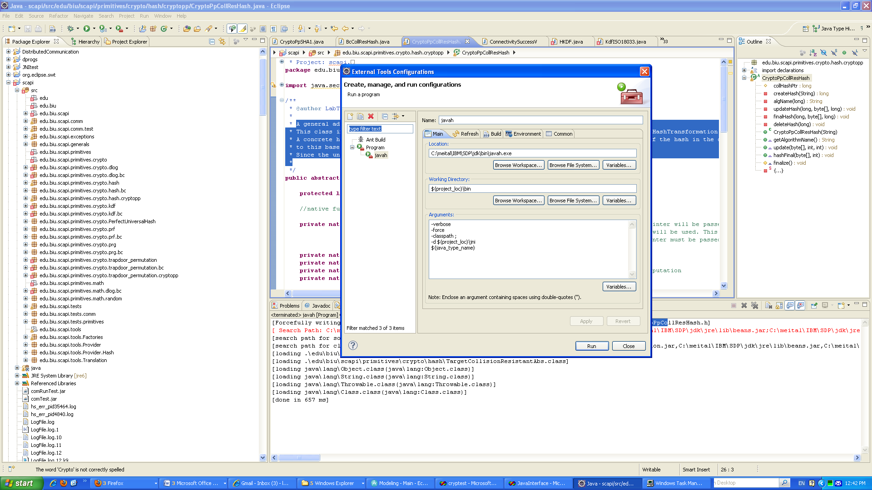

To generate the header file, select the related java file and run the javah external tool you have created as follows.

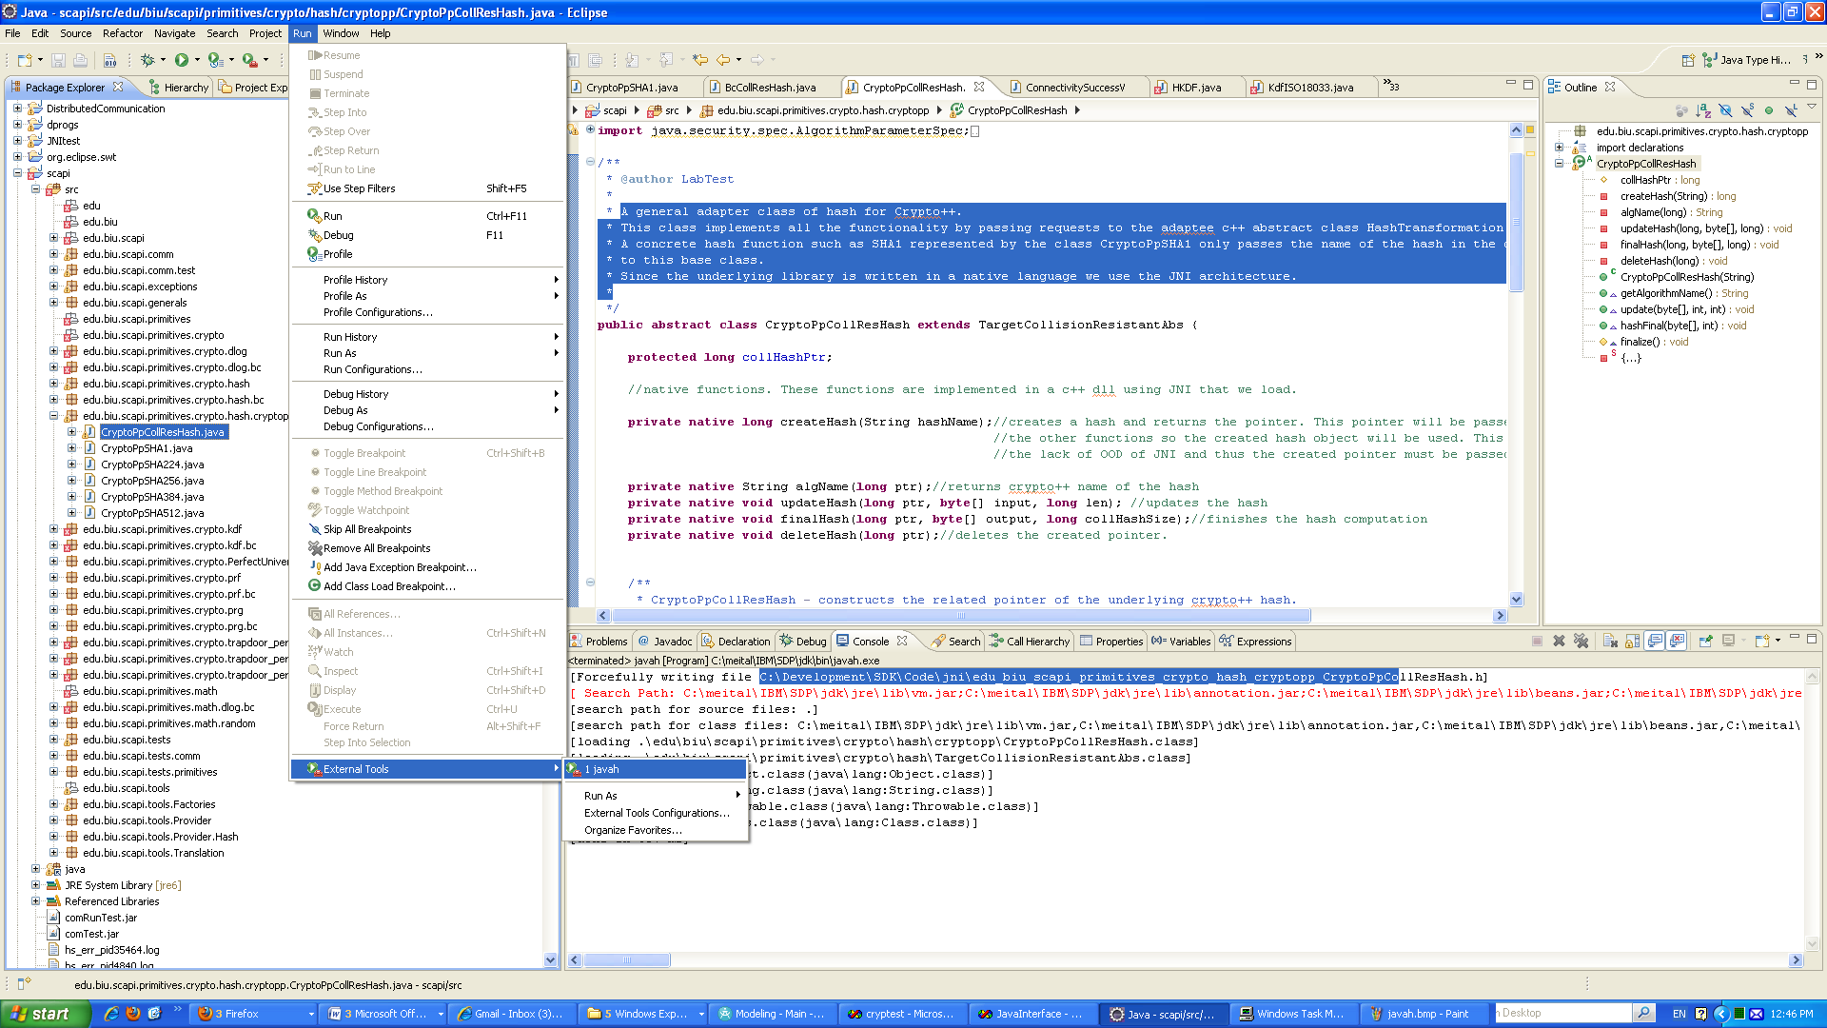

Note: In order for the tool to generate function signatures there must be some declaration of native functions. For example:

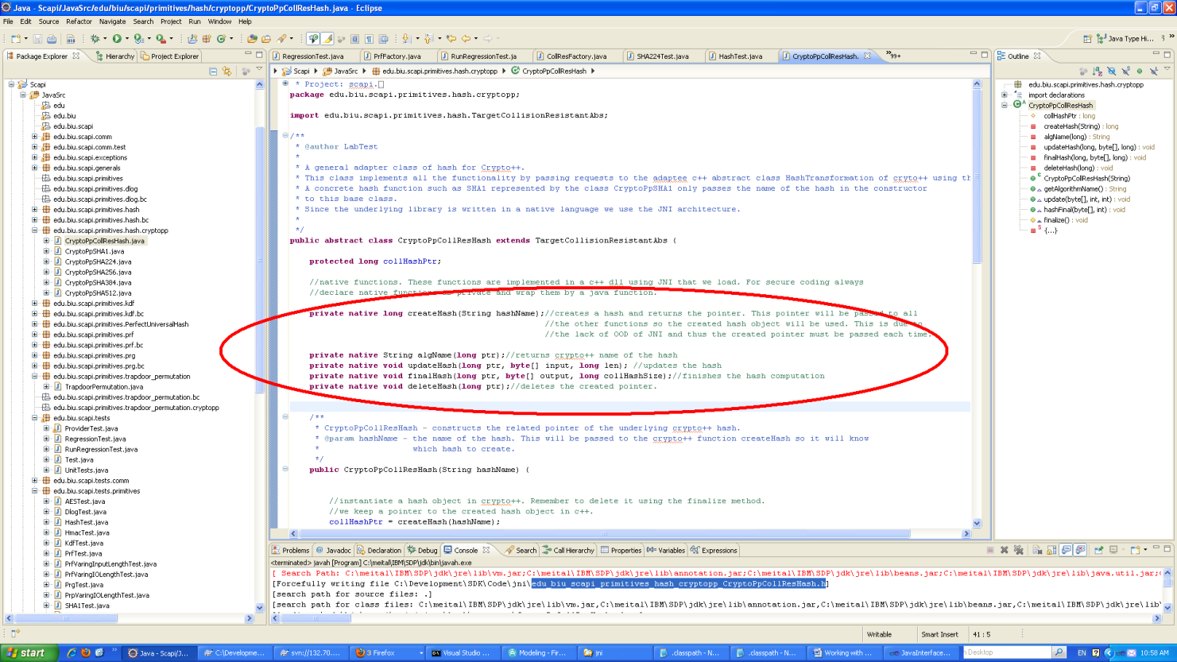

1. **Auto generated example file.**

An example of the generated h file from the external tool.

/* DO NOT EDIT THIS FILE - it is machine generated */

#include <jni.h>

/* Header for class edu_biu_scapi_primitives_hash_cryptopp_CryptoPpCollResHash */

#ifndef _Included_edu_biu_scapi_primitives_hash_cryptopp_CryptoPpCollResHash

#define _Included_edu_biu_scapi_primitives_hash_cryptopp_CryptoPpCollResHash

#ifdef __cplusplus

extern "C" {

#endif

/*

* Class: edu_biu_scapi_primitives_hash_cryptopp_CryptoPpCollResHash

* Method: createHash

* Signature: (Ljava/lang/String;)J

*/

JNIEXPORT jlong JNICALL Java_edu_biu_scapi_primitives_hash_cryptopp_CryptoPpCollResHash_createHash

(JNIEnv *, jobject, jstring);

/*

* Class: edu_biu_scapi_primitives_hash_cryptopp_CryptoPpCollResHash

* Method: algName

* Signature: (J)Ljava/lang/String;

*/

JNIEXPORT jstring JNICALL Java_edu_biu_scapi_primitives_hash_cryptopp_CryptoPpCollResHash_algName

(JNIEnv *, jobject, jlong);

/*

* Class: edu_biu_scapi_primitives_hash_cryptopp_CryptoPpCollResHash

* Method: updateHash

* Signature: (J[BJ)V

*/

JNIEXPORT void JNICALL Java_edu_biu_scapi_primitives_hash_cryptopp_CryptoPpCollResHash_updateHash

(JNIEnv *, jobject, jlong, jbyteArray, jlong);

/*

* Class: edu_biu_scapi_primitives_hash_cryptopp_CryptoPpCollResHash

* Method: finalHash

* Signature: (J[BJ)V

*/

JNIEXPORT void JNICALL Java_edu_biu_scapi_primitives_hash_cryptopp_CryptoPpCollResHash_finalHash

(JNIEnv *, jobject, jlong, jbyteArray, jlong);

/*

* Class: edu_biu_scapi_primitives_hash_cryptopp_CryptoPpCollResHash

* Method: deleteHash

* Signature: (J)V

*/

JNIEXPORT void JNICALL Java_edu_biu_scapi_primitives_hash_cryptopp_CryptoPpCollResHash_deleteHash

(JNIEnv *, jobject, jlong);

#ifdef __cplusplus

}

#endif

#endif

1. **Cut and Paste to a file in the JavaInterface project.**

After the function signatures have been created cut and past them to the related file in the JavaInterface project. IMPORTANT – DO NOT CHANGE THE SIGNATURE OF THE FUNCTIONS.

For example CollisionResistantHash.h.

